**Evaluation Only. Created with Aspose.Words. Copyright 2003-2022 Aspose Pty Ltd.**

2022

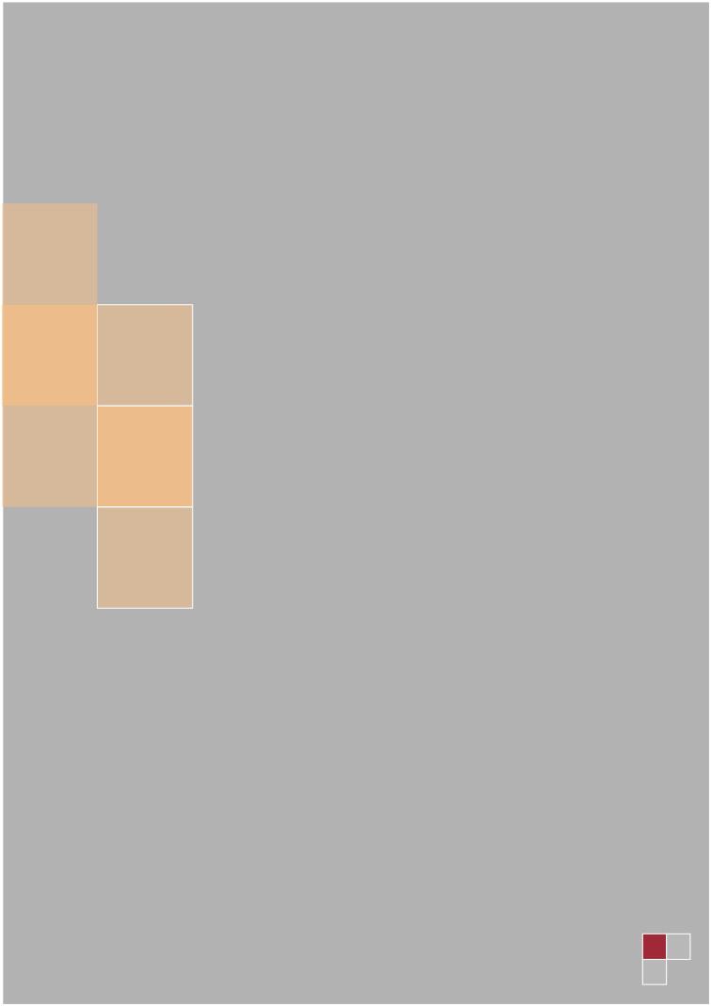

Sistemas Operativos y de Comunicaciones

Profesor: Lic. Tomas Casco

Néstor Hernán Juárez Susana Curzi

Cristian Ríos IFTS Nº12 2ºE

IFTS Nº12 | Confidencial